Table of Contents

1 DOCUMENT HISTORY, VERSION, AND AUTHORS 4
1.1 Document Version and Authors 4
2 ACRONYMS 5
3 DOCUMENT PURPOSE AND EXECUTIVE SUMMARY 7
3.1 Executive Summary 7
3.2 Purpose 7
4 Context and Scope 8
4.1 Business Context 8
4.2 Technical Scope – Multi-account architecture 8
4.3 Development phase considerations 9
5 ARCHITECTURal Overview 11
5.1 Security Architecture principles 11
5.2 Multi-account Architecture 11
5.3 Data Flow security Model 13
5.4 integration with organization security infrastructure 14
6 Shared Responsibility Matrix 15
6.1 AWS Shared Responsibility Model 15
6.2 Account Specific Responsibility Allocation 15
6.3 Cross Account Responsibilities 15
7 Thrreat Model and Assumptions 17
7.1 Threat Landscape Assessment 17
7.2 Attack Vector Analysis 17
7.3 Security Assumptions 18
8 Identity and ACcess Controls 19
8.1 Multi-Account Identity Architecture 19
8.2 Role Based Access Control (RBAC) 19
8.3 Multi-Factor Authentication (MFA) 20
8.4 Privileged Access Management (PAM) 20
9 Network Security 21
9.1 Multi-Account Network Architecture 21
9.2 Perimeter Security Controls 21
9.3 Network Segmentation and Micro-segmentation 22
10 Crypto and Key management 23
10.1 Encryption Strategy 23
10.2 Key Management Architecture 23
10.3 Secret Management 23
11 Logging and Monitoring 25
11.1 Centralised Logging Architecture 25
11.2 Security Monitoring 27
11.3 Automated Threat Detection 28
12 Vulnerability and Threat Detection 29
12.1 Vulnerability Management 29
12.2 Threat Intelligence Integration 30
12.3 Incident Detection and Response 30
13 Data Classification and Handling 31
13.1 Government Security Classifications Implementation 31
13.2 Automated Data Classification 31
13.3 Classification-Based Access Controls 31
14 Business Continuity and Disaster Recovery 33
14.1 Single-Region Resilience Strategy 33
14.2 Account-Level Resilience 33
14.3 Recovery Procedure 33
15 Secure SDLC/DevSecOps PipeLine 35
15.1 Development Security Integration 35
15.2 Automated Security Gates 35
15.3 Infrastructure as Code Security 36
16 Third Party/Supply Chain risk 37
16.1 Vendor Risk Management Framework 37
16.2 Software Supply Chain Security 37
17 AWS Security Services Overview 38
18 DOCUMENTS REFERENCED 40

DOCUMENT HISTORY, VERSION, AND AUTHORS
Heading Text goes here

Document Version and Authors

Date | Version | Name | Role | Comments
15 July 2025 | 0.1 | Abdul Khader Abdul Hanif, Sam Mathew, Viswanathan Mareeswaran | Cloud Security Architects | Initial version
17 July 2025 | 0.2 | Abdul Khader Abdul Hanif, Sam Mathew | Cloud Security Architects | Updated document based on input received from Infrastructure and project team
21 July 2025 | 1.0 | Sam Mathew | Cloud Security Architects | Final version for customer review

ACRONYMS
Acronym | Definition
ACL | Access Control List
ACM | AWS Certificate Manager
API | Application Programming Interface
APT | Advanced Persistent Threat
AWS | Amazon Web Services
BoM | Bill of Material
CICD | Continuous Integration and Continuous Delivery
CMK | Customer Managed Key
CSPM | Cloud Security Posture Management
CVE | Common Vulnerability and Exposures
DDoS | Distributed Denial of Service
DIST | Department for Science, Innovation & Technology
DNS | Domain Name Service
EBS | Amazon Elastic Block Store
ECR | Amazon Elastic Container Registry
EKS | Amazon Elastic Kubernetes Service
GDPR | General Data Protection Regulation
HLD | High Level Design
HTTP | Hypertext Transfer Protocol
IAM | Identity and Access Management
KMS | Key Management Service
MFA | Multi-Factor Authentication
NCSC | National Cyber Security Centre
NIST | National Institute of Standards and Technology
OWASP | Open Web Application Security Project
PAM | Privileged Access Management
RBAC | Role Based Access Control
RDS | Relational Database Service
RPO | Recovery Point Objective
RTO | Recovery Time Objective
SAST | Static Application Security Testing
SBOM | Software Bill of Material
SCA | Software Composition Analysis
SDK | Software Development Kit
SIEM | Security Information and Event Management
SOC | Security Operations Centre
SSH | Secure Shell
SSO | Single Sign-On
TLS | Transport Layer Security
VPC | AWS Virtual Private Cloud
WAF | Web Application Firewall

DOCUMENT PURPOSE AND EXECUTIVE SUMMARY

Executive Summary
This document provides a comprehensive security-specific High-Level Design (HLD) for the Matrix (neo) Integration Hub, a cloud-based data exchange platform designed to facilitate secure data integration between Workday SaaS, financial systems, and downstream applications within the DSIT organisation. The platform leverages Amazon Web Services (AWS) infrastructure and implements a zero-trust security architecture aligned with the National Cyber Security Centre (NCSC) Cloud Security Principles and AWS Well-Architected Security Pillar.
The Matrix Integration Hub serves as a critical component in the organisation's data ecosystem, handling sensitive government data through secure SFTP and HTTPs interfaces. This design ensures compliance with integration hub security requirements agreed as part of the Schedule 02 and Schedule 05 whilst maintaining operational efficiency and scalability. The architecture implements defence-in-depth security controls, comprehensive monitoring, and automated threat detection capabilities to protect against evolving cyber threats. Key security features include end-to-end encryption, multi-factor authentication, network segmentation and continuous monitoring. The design incorporates lessons learned from industry best practices and aligns NCSC standards.

Purpose
This Security High-Level Design document serves multiple critical functions within the Matrix Integration Hub project lifecycle. Primarily, it captures the agreed security architecture based on the Bill of Materials (BoM), establishing a canonical reference for all security-related decisions and implementations. The document maps security controls to industry-recognised baselines including the NCSC Cloud Security Principles, CIS AWS Foundations Benchmark and NIST Cybersecurity Framework.
The design addresses the unique security challenges associated and it establishes clear security boundaries, defines roles and responsibilities, and provides a framework for continuous security improvement and adaptation to emerging threats.

Context and Scope

Business Context
The Matrix Integration Hub represents a strategic initiative to modernise the organisation's data integration capabilities, replacing legacy point-to-point integrations with a centralised, secure, and scalable platform. Currently in the development phase, the hub is designed to facilitate data exchange between critical business systems including Workday SaaS for human resources management, various financial systems for budget and procurement data, and downstream applications supporting operational decision-making.
The platform operates within a regulatory environment aligned to NCSC security guidance. The organisation handles data across multiple classification levels, from routine OFFICIAL information to SENSITIVE PII information, requiring robust security controls and clear segregation mechanisms even during the development phase.
The new platform provides a foundation for implementing consistent security policies, automated monitoring, and standardised data handling procedures across all integration points whilst supporting iterative development and testing activities.

Technical Scope – Multi-account architecture
The security design encompasses all components of the Matrix Integration Hub infrastructure across the workload and non-workload account architecture, including ingress and egress data flows, processing components, storage systems, and management interfaces. The scope includes security controls for data in transit, data at rest, and data in processing, covering the complete data lifecycle from initial ingestion through final delivery to downstream systems.
Workload and non-workload environment comprise of the AWS accounts below:

Workload accounts: Prod, Pre-Prod, NFT, End-To-End(E2E) and Development (DEV) AWS accounts

Non-Workload Accounts: Network, Security, Logging. Shared AWS accounts

- Neo-network Account: Handles all ingress and egress traffic patterns with CheckPoint Cloud Guard firewall providing perimeter security and advanced threat protection. This account serves as the primary security gateway for all external communications and implements comprehensive network security controls.
- Neo-sharedservices Account: Hosts development-focused security services including Amazon Elastic Container Registry (ECR) with vulnerability scanning using Amazon Inspector, and Amazon CodeGuru integrated with CI/CD pipelines for automated code security analysis. This account provides centralised security tooling for the development lifecycle.
- Neo-securityaudit Account: Serves as the central audit account hosting aggregators for all security services findings, including AWS Security Hub CSPM (Cloud Security Posture Management), Amazon GuardDuty for threat detection, AWS Config for configuration compliance, Amazon Inspector for vulnerability assessment, AWS Access Analyzer for access policy analysis, and Amazon Macie for data security monitoring. This account is designed for future integration with the Security Operations Centre (SOC), particularly for GuardDuty findings analysis.
- Neo-logging Account: Provides centralised logging capabilities hosting Amazon S3 buckets for all audit and access logs across the platform. This account is essential for triaging issues as part of incident management and maintaining comprehensive audit trails for compliance purposes.
- Workload Accounts: Hosts the core integration platform components including AWS Web Application Firewall (WAF) associated with API Gateway to intercept incoming traffic and evaluate against OWASP Top 10 rulesets, AWS Secrets Manager for secure credentials storage, and AWS Certificate Manager for public certificate management.
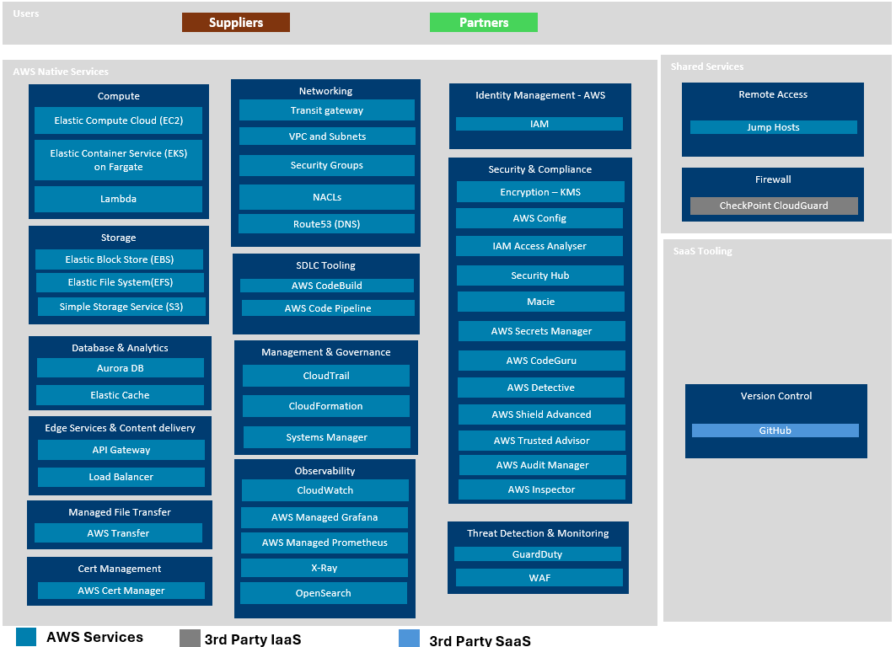

Development phase considerations
The current development phase requires specific security considerations that balance robust protection with development agility. Security controls are implemented to protect development data and infrastructure whilst enabling rapid iteration and testing of integration workflows. The multi-account structure provides natural isolation between different functions whilst maintaining centralised security monitoring and compliance oversight.

Development security practices include secure coding standards enforced through CodeGuru integration, automated vulnerability scanning of container images through Inspector, and comprehensive logging of all development activities for security analysis and compliance purposes. The architecture supports secure development practices whilst preparing for eventual production deployment with minimal security control modifications.

ARCHITECTURal Overview

Security Architecture principles
The Matrix Integration Hub security architecture is founded upon zero-trust principles, which assume that no network, device, or user should be trusted by default, regardless of their location or previous authentication status. This approach is particularly relevant for government organisations that must protect against sophisticated threat actors and insider threats whilst maintaining operational efficiency during development and eventual production operations.
The architecture implements defence-in-depth strategies with multiple layers of security controls distributed across the workload and non-workload account structure, ensuring that the compromise of any single component does not result in complete system failure. Each account provides independent security capabilities whilst contributing to the overall security posture through coordinated monitoring and response mechanisms centralised in the Neo-securityaudit account.
Security controls are designed to be transparent to legitimate users whilst providing robust protection against unauthorised access attempts. The architecture emphasises automation wherever possible to reduce the risk of human error and ensure consistent application of security policies across all platform components and accounts.

Multi-account Architecture
The security design encompasses all components of the Matrix Integration Hub infrastructure across the Workload and non-workload account architecture, including ingress and egress data flows, processing components, storage systems, and management interfaces. The scope includes security controls for data in transit, data at rest, and data in processing, covering the complete data lifecycle from initial ingestion through final delivery to downstream systems.
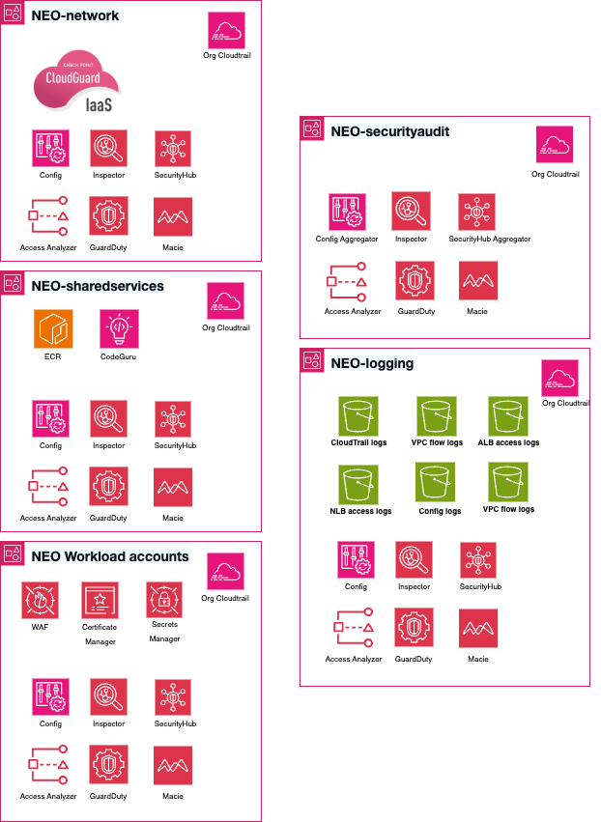

Account | Purpose
Neo-network | - Handles Ingress and Egress Traffic pattern with CheckPoint Cloud Guard firewall
Neo-sharedservices | - ECR vulnerability scanning using Inspector  - CodeGuru integrated with CI/CD for code scanning
Neo-securityaudit | - Central audit account hosting aggregators for all security services findings covering Security Hub CSPM, GuardDuty, Config, Inspector, Access Analyzer and Macie.  - Future integration with SOC especially for GuardDuty findings analysis.
Neo-logging | - Central logging account hosting S3 buckets for all the audit and access logs.  - Useful for triaging any issues as part of incident management
Workload accounts | - Hosts AWS WAF for association with API Gateway to intercept incoming traffic and evaluates against OWASP Top 10 rulesets  - Secrets Manager for credentials storage  - AWS Certificate Manager for Public cert Management

Data Flow security Model
Data flows through the integration hub follow a structured security model that ensures appropriate protection at each stage of processing across the multi-account architecture. Incoming data from Workday SaaS and other external sources is initially received through the Neo-network account's CheckPoint Cloud Guard firewall, which provides comprehensive threat detection and prevention capabilities.
Upon passing perimeter security controls, data flows to the workload account where API Gateway with integrated WAF performs application-layer security validation including OWASP Top 10 protection. Valid data is then processed through transformation engines that operate within isolated execution environments to prevent cross-contamination between different data sources.

The data from upstream sources, during the processing within Integration Hub will be stored in encrypted form within secure storage systems that implement role-based access controls and comprehensive audit logging. All data access activities are logged to the Neo-logging account for centralised audit trail management and compliance reporting. Data egress follows similar security procedures via Checkpoint CloudGuard Firewall, with additional validation to ensure that only authorised recipients receive appropriate data subsets based on their access permissions and business requirements.

integration with organization security infrastructure

The Matrix Integration Hub integrates seamlessly with the organisation's existing security infrastructure, leveraging established identity providers, security monitoring systems, and incident response procedures. This integration ensures consistent security policies across all organisational systems whilst avoiding duplication of security capabilities.
The platform has implemented AWS Single Sign-On (SSO) using IAM Identity Center, enabling single sign-on capabilities, MFA and centralised user lifecycle management across all accounts. Security events generated by the integration hub are aggregated in the Neo-securityaudit account and can be forwarded to the organization’s Security Information and Event Management (SIEM) system for correlation with events from other organisational systems.

Shared Responsibility Matrix

AWS Shared Responsibility Model

The AWS Shared Responsibility Model forms the foundation for understanding security responsibilities within the Matrix Integration Hub's multi-account architecture. AWS assumes responsibility for the security "of" the cloud, including the physical infrastructure, hardware, software, networking, and facilities that run AWS services across all accounts.

AWS maintains responsibility for the hypervisor and below, including the physical security of data centres, environmental controls, power systems, and network infrastructure. AWS also manages the security of managed services such as Amazon RDS, Amazon S3, AWS Lambda, and the specialised services used across the platform including Security Hub, GuardDuty, Inspector, and Detective.
The organisation assumes responsibility for security "in" the cloud across all accounts, including customer data, identity and access management, operating system updates and security patches for EC2 instances, network traffic protection through security groups and network ACLs, and application-level security controls implemented within each account.

Account Specific Responsibility Allocation

Security Domain | AWS Responsibility | Neo-network | Neo-sharedservices | Neo-securityaudit | Neo-logging | Workload Accounts
Physical Security | Data centre security, environmental controls | - | - | - | - | -
Network Infrastructure | VPC infrastructure, AWS backbone | Firewall config | - | - | - | Network policies
Identity Management | IAM service availability | - | Service accounts | Audit roles | Log access roles | App user management
Data Protection | Encryption services (KMS) | Traffic encryption | Image encryption | Finding encryption | Log encryption | Data encryption
Monitoring & Logging | Service infrastructure | Traffic logs | Build logs | Security findings | Centralised logs | Application logs
Vulnerability Management | Service patching | Firewall updates | Scanner updates | Tool updates | Storage updates | App patching

Cross Account Responsibilities

The multi-account architecture introduces additional complexity in responsibility allocation, particularly for cross-account access and security monitoring. Cross-account IAM roles enable secure communication between accounts whilst maintaining appropriate access controls and audit trails.

The Neo-securityaudit account assumes responsibility for aggregating and analysing security findings from all other accounts, requiring appropriate cross-account permissions to collect security data whilst maintaining the principle of least privilege. This centralised monitoring approach ensures comprehensive security visibility whilst maintaining account isolation.

The Neo-logging account serves as the central repository for audit data from all accounts, requiring secure cross-account log delivery mechanisms and appropriate retention policies. This account must maintain the integrity and availability of audit data whilst providing appropriate access for incident investigation and compliance reporting.

The Neo-sharedservices account hosts the central ECR registry that contains all the container images and inspector scanning is performed against this registry to identity, report and remediate vulnerabilities

The Neo-network account forms the central hub with rest of the accounts serving as spokes. It hosts the Checkpoint CloudGuard firewall that enables the central ingress and egress capability for the platform and effectively providing the IPS capability.

Thrreat Model and Assumptions

Threat Landscape Assessment

The Neo Integration Hub operates within a threat environment characterised by sophisticated nation-state actors, organised cybercriminal groups, and potential insider threats targeting UK government systems. The platform's role as a central data integration point makes it an attractive target for adversaries seeking to gain access to sensitive government information or disrupt critical business operations.

Advanced Persistent Threat (APT) groups represent the most significant external threat, possessing sophisticated capabilities including zero-day exploits, advanced social engineering techniques, and the resources to conduct long-term campaigns against government targets. These actors may attempt to compromise the platform through various attack vectors including supply chain attacks against third-party components, spear-phishing campaigns targeting authorised users, and exploitation of vulnerabilities in internet-facing services.

Cybercriminal organisations pose additional threats through ransomware attacks, data theft for financial gain, and business email compromise schemes targeting the organisation's personnel. These threats are particularly relevant during the development phase when security controls may be less mature and development data may be perceived as easier targets.

Insider threats encompass both malicious insiders with legitimate access who may abuse their privileges for personal gain or ideological reasons, and unintentional insider threats resulting from human error, social engineering, or inadequate security awareness. The multi-account architecture provides natural boundaries to limit the potential impact of insider threats.

Attack Vector Analysis

